Khảo sát project

* Entity:

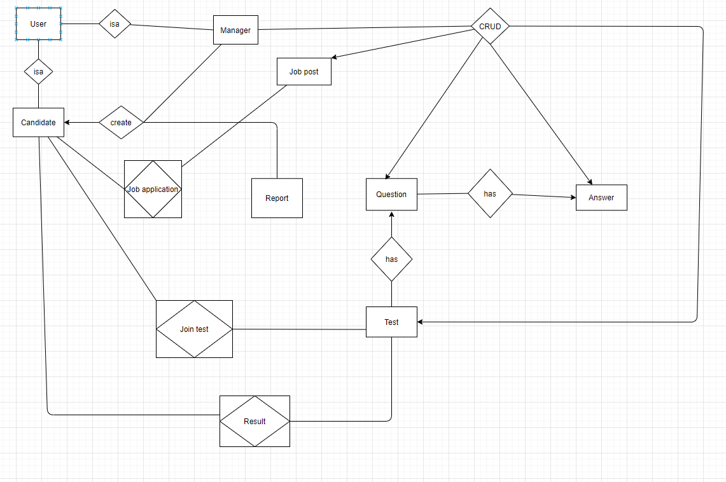

* + User:
    - Manager
    - Candidates
  + Question
  + Answer
  + Test
  + Report
  + Job post
  + Job application
  + Joint test
* Use case:
  + User:
    - * Login
    - Manager:
      * Manage users: CRU
      * Manage tests: CRU
      * Manage questions and answers: CRUD
      * Create report
      * Mail candidate test detail and candidate account
      * Manage job register
      * Manage job application
    - Candidate:
      * Do tests
      * See result
      * Apply job

